**INCEPTION**

***Hello world using HTML***

Simply type html:5 in vs code it will generate basic html code with header and body by making use of emmet

<!DOCTYPE html>

<html lang="en">

<head>

    <meta charset="UTF-8">

    <meta http-equiv="X-UA-Compatible" content="IE=edge">

    <meta name="viewport" content="width=device-width, initial-scale=1.0">

    <title>Document</title>

</head>

<body>

    <div id="root">

        <h1>Hello world</h1>

    </div>

</body>

</html>

***Hello world from JavaScript***

<!DOCTYPE html>

<html lang="en">

<head>

    <meta charset="UTF-8">

    <meta http-equiv="X-UA-Compatible" content="IE=edge">

    <meta name="viewport" content="width=device-width, initial-scale=1.0">

    <title>Document</title>

</head>

<body>

    <div id="root">

    </div>

    <script>

        let heading = document.createElement('h1');

        heading.innerHTML = 'Hello world form JavaScript';

        let root = document.getElementById('root');

        root.appendChild(heading);

    </script>

</body>

</html>

***Injecting React superpowers using CDN***

* We have to add two CDN links one is for React core (react.development.js) another one is for DOM operations (react-dom.development.js).
* React have two CDN because the core react we will be able to use with other react based apps such as React Native, React 3D etc.

<!DOCTYPE html>

<html lang="en">

<head>

    <meta charset="UTF-8">

    <meta http-equiv="X-UA-Compatible" content="IE=edge">

    <meta name="viewport" content="width=device-width, initial-scale=1.0">

    <link rel="stylesheet" href="./index.css">

    <title>Document</title>

</head>

<body>

    <div id="root"></div>

    <script crossorigin src="https://unpkg.com/react@18/umd/react.development.js"></script>

    <script crossorigin src="https://unpkg.com/react-dom@18/umd/react-dom.development.js"></script>

</body>

</html>

***Hello world from React***

<body>

    <div id="root"></div>

    <script crossorigin src="https://unpkg.com/react@18/umd/react.development.js"></script>

    <script crossorigin src="https://unpkg.com/react-dom@18/umd/react-dom.development.js"></script>

    <script>

        let heading = React.createElement('h1', {id: 'heading'}, 'Hello world from React');

        let root = ReactDOM.createRoot(document.getElementById('root'));

        root.render(heading);

    </script>

</body>

* The createElement() method of React is having three arguments they are Tag, Attributes and children respectively
* createElement(<tag>, <attributes>, <children> or [<child1>, <child2>])
* CreateElement() will return an object which is having props, which is a combination of attributes and children
* Root is where all our react elements will get rendered
* All the contents we written inside the root elements will get replaced by the content which we will add with root.render() method
* We will be able to add React to an existing Jquery applications without affecting anything as it is a library
* Order in which the script imports do matter as well as the ‘root’ where we render the React, that can be small portion of the page as well

Complex structure implementation ex:

 *  <div id="parent">

 *      <div id="child">

 *          <h1>I'm an h1 tag :) </h1>

 *          <h2>I'm an h2 tag :) </h2>

 *      </div>

 *      <div id="child2">

 *          <h1>I'm an h1 tag :) </h1>

 *          <h2>I'm an h2 tag :) </h2>

 *      </div>

 *  </div>

 */

let parent = React.createElement('div', { id: 'parent'}, [

        React.createElement('div', { id: 'child'},[

            React.createElement('h1', {}, "I'm an h1 tag"),

            React.createElement('h2', {}, "I'm an h2 tag")

        ]),

        React.createElement('div', { id: 'child2'},[

            React.createElement('h1', {}, "I'm an h1 tag"),

            React.createElement('h2', {}, "I'm an h2 tag")

        ])

    ]);

let root = ReactDOM.createRoot(document.getElementById('root'));

root.render(parent);

**IGNITING OUR APP**

* To make our code production ready code we should remove comments and console, also should do code minification, bundling, splitting, image optimization, chunking,
* React works so fast is not only because of its performance but, it’s also with the additional packages we add to work along with it
* NPM is not node package manager instead it will manage packages
* Create-react-app It automatically has NPM inside it
* To make our project use NPM, we can add NPM to our project by using

*npm init* command with relevant inputs which generate package.json

* Package.json – It is a configuration for NPM also helps on dependency management by its version
* Most important package: bunder
* Bundlers are used to bundle/packages our app so that it will be production ready

IE: minified, cached, compressed, cleaned

* Bundler ex: Webpack, Parcel, Wheat
* create-react-app uses Webpack as the bundler (Webpack and bebel)
* npm install -D parcel

There are two type of dependencies one is dev and the other is normal (used in all, ie in production as well)

Dev is used only in the development phase

-D is used to indicate that it is a dev dependency

* In package.json if we have versions with

~ as prefix which indicate that it will allow automatic patch updates

^ as prefix, it will allow patch and minor updates

[major. minor. patch]

* package.json will keep track of what version of package installed into our system and will have ~ or ^ to mark how it can upgrade
* package-lock.json will keep a track of exact version that is being installed
* integrity key is basically having a hash which will make sure the deployed version is same as in the local
* Transitive dependency – dependency chain of dependencies,

In our case we need parcel as dependency but parcel have its own dependency, that each dependency has their own dependencies and so on. Thus, it’s a transitive dependency

* In effect will be having a lot of package.json files because each of our dependencies have its own (1.08 in video revision)
* npm <cmd> is used to install a package, npx <cmd> is used to execute a package
* npx parcel index.html -> used to ignite out app
* As of now we added React into our app using CDN, we will be able to add via NPM as well
* CDN links are not a right way to inject React into our app,
  + If there is a network delay it might affect it.
  + We have to keep on updating the links if there is version update
* Browser scripts cannot have imports or exports. -> We will get such an error if we try to import/export any files in normal JS files to resolve it we have to add type=”module” as an attribute in script tag where we import our JS file
* By using type=”module” -> It will considered as module
* npx parcel index.html

Parcel will go to our index.html and build a dev build of our app and host that build into localhost

* Commands to insall React using NPM

npm i react

npm i react-dom

* Just after this installation, if we remove our CDNs and try to execute our app using parcel will fail as we didn’t inject React to our app
* Importing React into our app

import React from ‘react’

import ReactDOM from ‘react-dom/client’

Now if we try to execute our app, it will fail as we added the JS file as normal script import <script src=”/App.js”></script

To make it work use <script type=”module” src=”/App.js”></script> so that browser will consider it as module

* Parcel

Dev Build

Local Server

HMR = Hot Module Replacement

File Watching Algorithm – written in C++

Caching – Faster build (.parcel-cache)

Image Optimization

Minification

Bundling

Compress

Consistent Hashing

Code Splitting

Differential Bundling – support older browsers

Diagnostics

Error Handling

HTTPs

Tree Shaking – Remove unused code for us

Different dev and prod builds

* HMR

We will be able to see the auto refresh of our app whenever we made any change and save the code, it done with the help of HMR which uses file watching algorithm

* Prod build

npx parcel build index.html // ‘build’ will helps to make prod build

We have to remove ‘main: ”App.js”’ from package.json as we already give the entry point as index.html for parcel

* browserlist

We have to use browserlist to make our app support older browser

We will be adding it in package.json

Even if we add browser list configuration only for chrome but still it will work in other browsers but there is no guarantee it will not break

Refer : <https://browserslist.dev/?q=bGFzdCAyIHZlcnNpb25z>

By adding browserlist only for a specific browser, we can reduce the bundle size

It can be used for country specific bundling as well

**LAYING THE FOUNDATION**

***NPM Scripts***

* Instead of writing the command ‘npx parcel index.html’. We should make use of npm scripts to start our application for that we have to add the dev and prod build scripts in package.json

Eg:

"scripts": {

    "start": "parcel index.html",

    "build": "parcel build index.html",

    "test": "jest"

  },

* Once we have the scripts ready, we can execute it using

npm run <name of the script>

eg: npm run start

* ‘npm run start’ is similar to ‘npm start’
* We can add ‘Not Rendered’ inside the content of div id root. It will be helpful to identify there is any problem in rendering

***JSX***

* Syntax to create React Element, used to write HTML in React
* JSX syntax to create React Element

const jsxHeading = <h1 id="heading">Namste React using JSX</h1>

* React Syntax to create React Element

const heading = React.createElement("h1", { id: "heading"}, "Namste React🚀");

* JSX is not part of React
* We can create React Apps without JSX also
* Which will merge the HTML and JS
* It is not HTML in JS, It is HTML like syntax
* React Element using JSX eg:

<h1 id=”heading”> Namaste React </h1>

* JSX is not a valid pure Javascript because JS engine will understand only ECMA script

Still we are able to execute it because of Parcel😊

* Parcel will transpiled our entire code before it reaches JS engine by using Babel
* Transpiation – Convert our code to make it understandable by Browser
* Babel
  + Javascript Compiler
  + Babel will transpile our code, so that React can understand it
  + Bable will do the following steps on JSX:

JSX -> Babel transpiles it to React.createElement() -> React Element (JS Object) -> HTML Element(render)

* In JSX the attributes should be in camel case, className is an attribute

const jsxHeading = <h1 className="head" >Namste React using JSX</h1>

* Multiline JSX code should enclosed between parenthesis
* VS Code Extensions:
  + Prettier
  + ESLint
  + Bracket Pair Colorization Toggler
  + Better Comments

***React Component***

* Class Based Components (OLD)
* Functional Components (NEW)

Class Based Components

* It uses JavaScript Classes to create components.

*Functional Components*

* Function that will return JSX code or React Element
* Uses JavaScript Functions to create components.
* We can use any ways to write the function like function statement, function expression or arrow function, Arrow function is the modern standard
* Component name should be in Pascal Case

const HeadingComponent = () =>

    <h1 className="heading">Namaste React Functional Compoents</h1>

Component Composition

* Component inside another component
* To make it work our incoming component should be in native HTML tag

const Title = () => {

  return (

    <h1 className="head" tabIndex="2">

      Namste React using JSX

    </h1>

  )

};

const HeadingComponent = () => (<div><Title />

    <h1 className="heading">Namaste React Functional Compoents</h1>

  </div>)

const root = ReactDOM.createRoot(document.getElementById("root"));

root.render(<HeadingComponent />);

JavaScript inside JSX

* We will be able to write/execute any JavaScript code/expression inside JSX by adding it in curly braces

const HeadingComponent = () => (

  <div>

    {console.log("Hey")}

    <h1 className="heading">Namaste React Functional Compoents</h1>

  </div>

)

* We can add a React element inside React Element

const header = <span>React Element </span>

const title =  (

    <h1 className="head" tabIndex="2">

      {header}         -> nested element

      Namste React using JSX

    </h1>

  )

* We can add a React element inside React Component

const title =  (

    <h1 className="head" tabIndex="2">

      Namste React using JSX

    </h1>

  )

const HeadingComponent = () => (

  <div>

    {title} -> element inside component

    <h1 className="heading">Namaste React Functional Compoents</h1>

  </div>

)

* We can add React Component inside React Element

const title =  (

  <div>

    <h1 className="head" tabIndex="2">

      Namste React using JSX

    </h1>

    <HeadingComponent/> - Component inside element

  </div>

  )

* JSX prevents XSS – Cross Site Scripting attacks by sanitizing the code
* We should add JS code or React Components within a parent tag, else it will throw error, It won’t allow siblings
* We can add React Components in three different ways

<div>

    {Title()}

    <Title/>

    <Title></Title>

    <h1 className="heading">Namaste React Functional Compoents</h1>

  </div>

* Custom attributes in JSX should be in lowercase

**TALK IS CHEAP SHOW ME THE CODE**

***Planning***

* Planning is key thing while building an application
* We should create a wireframe and identify the various components required for our app

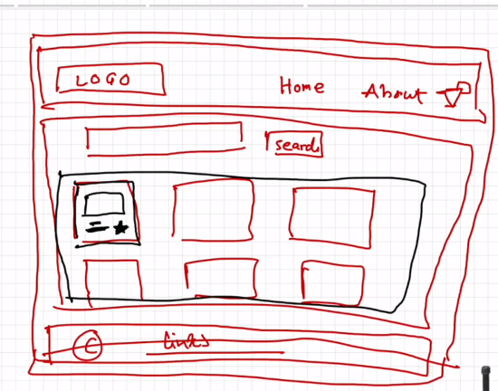

***Coding***

Style in JSX

* Styles can be inline or external in React
* For inline styles we will be using JS object

Ex:

Const styleCard = { backgroundColor: ‘red’ }  
<div style={styleCard}> </div>

Props

* Shortform for properties
* which we can pass to the components as arguments
* Props are normal arguments to a function
* Passing props to a component ~(Similar to) Passing arguments to a functions
* Whenever we need to pass any dynamic data to a component, then we will be making use of props
* React will wrap the props we pass into a component as an object

Ex:

Passing properties

<RestaurantCard resName="Top Form" cuisine="South Indian, Kerala"/>

<RestaurantCard resName="KFC" cuisine="Fast Food"/>

const RestaurantCard = (props) => {

  const {resName, cuisine} = props;

  return (

    <div className="res-card" style={resCardBackground}>

      <img

        className="res-logo"

        alt="res-logo"

        src="https://media-assets.swiggy.com/swiggy/image/upload/fl_lossy,f_auto,q_auto,w_660/b5303a94c367062c158ce278bf6307a3"/>

      <h3>{resName}</h3>

      <h4>{cuisine}</h4>

      <h4>4.4 Stars</h4>

      <h4>40 Minutes</h4>

    </div>

  )

}

**Config Driven UI**

* The websites driven by configs, so that by using a single application we can cover different scenarios

Ex:

If we consider a food ordering app like Swiggy, it’s offer and content will change based on location so the config is basically coming into picture here

**Loops**

* If we want to loop over components, we will be making use of JavaScript methods (map here).
* While we are looping over components, we should definitely give a ‘key’ attribute to uniquely identify component in loop. It’s basically a keyword
* The ‘key’ attribute helps in optimization while re-rendering the elements in the loop again with new element, by rendering only the new element and keeps the old elements rendered as it is.
* Key – For render cycle optimization
* As per official documentation, it’s not recommended to use index as ‘key’ for list element in loop

**{<TitleComponent/>} vs {<TitleComponent></TitleComponent>} in JSX**.

* Opening and closing tag is required when we need to add content in between, which will be considered as ‘children’ prop

**How can I write comments in JSX?**

* The syntax {/* */} to wrap around the comment text.

**What is <React.Fragment></React.Fragment> and <> </>?**

* Allows us to group elements without a wrapper node
* If we don’t need to add any props like ‘key’ then we can use the empty <></>

Else we should use <React.Fragment></React.Fragment> or <Fragment></Fragment>

**Virtual DOM?**

* The virtual DOM (VDOM) is a programming concept where an ideal, or “virtual”, representation of a UI is kept in memory and synced with the “real” DOM by a library such as ReactDOM. This process is called reconciliation.

**What is Reconciliation in React?**

* The process of syncing virtual DOM with the real. Which will use diffing algorithm to update the Real DOM by updating only the elements which got changed.
* Assumptions in change detection:
  + Two elements of different types will produce different trees.
  + The developer can hint at which child elements may be stable across different renders with a key prop.

**What is React Fiber?**

React Fiber is a concept of ReactJS that is used to render a system faster, smoother and smarter. The Fiber reconciler, which became the default reconciler for React 16 and above, is a complete rewrite of React’s reconciliation algorithm to solve some long-standing issues in React. Because Fiber is asynchronous, React can:

* Pause and restart rendering work on components as new updates come in
* Reuse previously completed work and even abort it if not needed
* Split work into chunks and prioritize tasks based on importance

**Why do we need keys in React?**

* Keys are used in React to identify which items in the list got modified

**Can we use index as keys in React?**

Yes, we can use the index as keys, but it is not considered as a good practice to use them because there will be negative impact when the order got changed

**LET’S GET HOOKED**

* One of the best practices is to create separate files for separate components
* React folder structure is depended on developer. It can be based on feature or file type etc.
* File name of a component should be same as component name as per convention
* We can make the component name extensions as .js or jsx both are same. If we use typescript then we have to use .tsx
* File export can be done in two ways
  + Default Export

If we have only one thing to export

Eg: export default <name_of_thing>

Import of default export: import <thing> from <path>

* + Named Export

To export multiple things

Eg: export const <thing1>

export const <thing2>

Import of named export: import { <thing1>, <thing2> } from <path>

* React is faster because of faster DOM manipulation as well

**Event Listeners**

* We will be able to use all default HTML event attributes
* In React we will use it as in camel case

Ex: onClick={()=>{ // Callback function which will be called on click

Console.log(‘button clicked’) //

}}

* We will be passing a callback to the event listeners to execute it

**Hooks**

* JavaScript utility functions given to us by React
* Two important Hooks are
  + useState() – To create super powerful state variables in React
  + useEffect()

**Variable using useState()**

* We can create a local state variable inside a component using useState()

Ex:

Header = () => {

Const [<variableName>, <setVariableName>] = useState(<defaultValue>)

}

* The < setVariableName > will be a method used to update the variable, as we will not be able to update it like a normal variable
* If we don’t want to update the variable then we don’t need the <setVariableName>
* State variables will work same as normal variable but we won’t be able to update it by variable assignment
* <setVariableName> - by convention we are naming it as a set prefix with variable name, but it can be any name
* State variables keeps the UI layer in sync with the data layer
* *Whenever the state variable updates, React will trigger the reconciliation cycle*

*(re-renders the component)*

* Used to create super powerful state variable, Its super powerful because React will keep track of state variables. Whenever the state variable updates React will trigger the diff algorithm and find the difference between Current Virtual DOM with Previous Virtual DOM and automatically updates the Actual DOM

**Reconciliation Algorithm (React Fiber)**

* React Fiber - It got introduced in React 16
* It’s a new way of finding the diff and updating the DOM
* Virtual DOM
  + Representation of Actual UI
  + Basically, a JavaScript Object

Ex: when we console a react element/component we will get a JavaScript Object

* *React is faster because of efficient DOM manipulation using React Fiber (explain..)*

As JavaScript Object comparison is faster than DOM tree comparison. Diff algorithm will make use of virtual DOM to compare and find the difference and then Updates the Actual DOM

* <setVariableName> is used to trigger the diff algorithm

**EXPLORING THE WORLD**

**Monolith**

* In monolith architecture everything will be in a single project

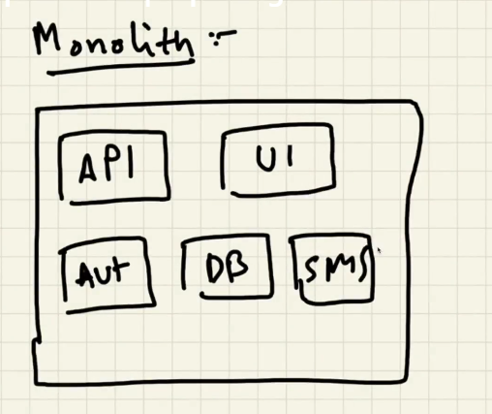

Eg: A single Java project which is having UI, API, Auth, DB etc, everything written in Java in a single repo. So, if we need to make any change in any single service (UI), we have to make the whole project deployment

**Microservices**

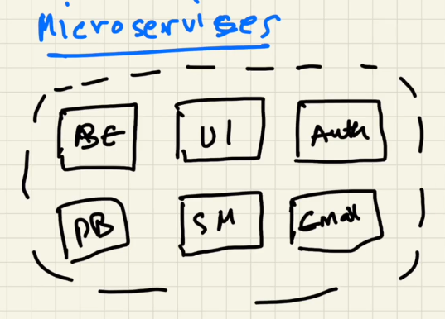

* Separation of concerns
* Single responsibility principle – Each and every service has its own job
* Here we can have separate repo for each service
* We will be able to use different tech stack for different service like React for UI, Python for backend etc. which we will choose by understanding which one is best for a specific service

**There are two approaches to interact with backend API**

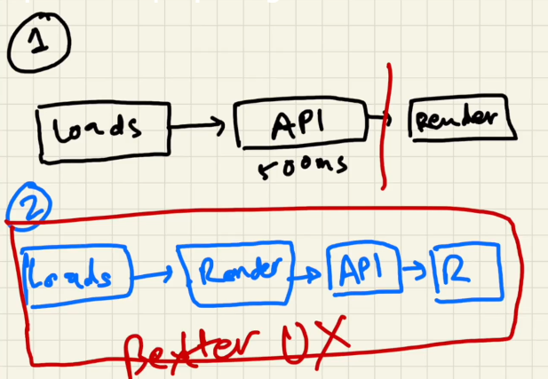

**The useEffect() Hook**

* Its like a normal function
* Syntax: useEffect(<callback()>, <dependency array>)
* The useEffect callback() method will be called after the component rendering
* It will be helpful to execute the code post rendering of our component

**CORS**

* Before the CORS policy, browsers won’t allow to communicate between cross origin

Which means

<https://abc.com> will not be able to communicate with

<https://def.com> – different domain

<https://api.abc.com> – different sub domain

<https://abc.com:5000> – different port

<http://abc.com> – without SSL

* As CORS is a web standard now, whenever our web app needs communicate with another one in different server, first it will send a preflight/options request and get a response. If the response header will have ‘Access-Control-Allow-Origin’ header as ‘*’ or our origin name then it can make the actual call else it will throw CORS error

**Shimmer UI**

* It makes better user experience by displaying fake UI instead of a loading spinner

**Conditional Rendering**

* Rendering content inside the Component based on certain condition

**Promise APIs**

* Following APIs are used to handle multiple promises
* Promise.all()
  + In Success scenario it will wait till all the promises to get resolved and return the result
  + In failure scenario, if any of the promise got rejected then it will return the result as rejected at that time itself

Ex: To handle multiple API calls

Promise.all([p1, p2, p3])

.then(result => {})

.catch(error => {})

* Promise.allSettled()
  + Irrespective of resolve or reject it will wait till all the promises to get **settled**
  + It will return an array of objects with result and status

Promise. allSettled ([p1, p2, p3])

.then(result => {})

.catch(error => {})

* Promise.race()
  + It will consider only the first promise which got settled

Promise. race([p1, p2, p3])

.then(result => {})

.catch(error => {})

* Promise.any()
  + It will wait to get at least one promise to get resolved,
  + If everything fails it will return Aggregated error

Promise. any([p1, p2, p3])

.then(result => {})

.catch(error => {})

**FINDING THE PATH**

**useEffect**

* The callback method argument is mandatory for useEffect(<callback>,<dependency array>)
* If no dependency array => useEffect is called on every component render

useEffect(() => console.log("header use effect"));

* If we have a dependency array, even its empty then the useEffect callback is called only once on its initial render

useEffect(() => console.log("header use effect"), []);

* If we have anything inside dependency array then the useEffect callback is called everytime when the dependency changes, along with the initial render call

const [btnName, setBtnName] = useState("Login");

useEffect(() => console.log("Use effect called"), [btnName]);

**useState**

* Never create a state variable out of our component body, as it causes error
* Used to create local state variables inside the functional components
* We should call it on the top i.e. the start of the function
* It’s not recommended to create state variables inside our if conditions as it causes inconsistency to our program
* It’s also not recommended to create state variables inside for loop and functions

**React router DOM**

* For routing in react
* We will be adding routing config in App.js. The main file

createBrowserRouter

* Used to create routing configuration
* Routing configuration – Which will define when we access a path what should happen
* We will be defining routes as an array of objects, in which each object will represents a route. Which will contain a path and element

const appRouter = createBrowserRouter([

  {

    path: "/",

    element: <AppLayout/>

  },

  {

    path: "/about",

    element: <About />

  }

]);

* We should provide the defined routes to render. For that we will be making use of RouterProvider component

root.render(<RouterProvider router={appRouter} />);

* If we simply type ‘rafce’ in VS Code. It will create a react component

Error Handling

* If the user enters a path which is not defined then react-router-dom will redirect to its error page. If we need to display our custom error page, then we should define it in route object on errorElement property as a component
* We will be defining the errorElement property in the root/home route object

  {

    path: "/",

    element: <AppLayout/>,

    errorElement: <Error />

  },

* We can identify hooks by checking the ‘use’ prefix
* useRouteError – Hook provided by react-router-dom to get the error details when there is an error with route, like not found

const Error = () => {

  const err = useRouteError();

  return (

    <div>

      <h1>Oops!!!</h1>

      <h2>Something went wrong!!</h2>

      <h3>

        {err.status}: {err.statusText}

      </h3>

    </div>

  );

};

Child Routes

* There are scenarios when a component should be fixed and others are dynamic like  
  Header is fixed and body can change according to routes. In such scenarios we can make use of child routes
* The child routes are defined inside the route object under ‘children’ property as an array of route objects

{

    path: "/",

    element: <AppLayout />,

    errorElement: <Error />,

    children: [

      {

        path: "/",

        element: <Body />,

      },

      {

        path: "/about",

        element: <About />,

      },

      {

        path: "/contact",

        element: <Contact />,

      },

    ],

  }

* We should mark place in the parent component where the child routes need to be displayed according to the path by using ‘Outlet’ component of react-router-dom

<div className="app">

      <Header />

      <Outlet />

    </div>

Link Component

* Link component of react-router-dom - used to navigate between components.
* If we try to use href it will reload the entire application.
* Link component is similar to anchor tag, the difference is, it will use ‘to’ instead of ‘href’

<Link to="/about">About Us</Link>

* The routes are helping us to achieve the single page application concept

**Routing in web apps**

* Client Side Routing
  + Without making a network call and navigating between pages
  + Single page applications
* Server Side Routing
  + Making a network call and navigating between pages
  + Legacy web apps

**Dynamic Routes**

* We can define a dynamic route in route object by making the value of path as a string having colon prefix variable name after the slash

{

        path: "/restaurant/:resId",

        element: <RestaurantMenu />,

}

* We will be using ‘useParams’ hook from react-router-dom for getting dynamic route parameters

const params = useParams();

* Link component is a wrapper over anchor tag

It will be rendered as an anchor tag in UI



**Add Images into our App**

* Importing from local directory

import logo from "./../reactLogo.jpg";

<img src={logo} />

* Externally hosted image

<img src="https://logos-world.net/wp-content/uploads/2023/08/React-Logo-500x281.png" />

**useState console**

console.log(useState(""));



**LET’s GET CLASSY**

**Class based components**

* Javascript Class which extends React.Component to make it as component
* Which will have a render method that returns JSX
* *Javascript Class which extends React.Component and have render method which will return piece of JSX code*
* Once we created the class we should export, import and implement it as we do the functional component

class UserClass extends React.Component {

  render() {

    return (div className="user-card">div>);

  }

}

**Passing Props into class-based components**

* We can pass it in the same way as in functional components

<UserClass name="Mikhil Class" location="Calicut class" />

* But while receiving it we will be getting it inside the constructor

class UserClass extends React.Component {

  constructor(props) {

    super(props);

  }

  render() {}

}

* Here we should use super(props) method to call the parent class constructor with the props
* Using ‘this’ keyword we can access the props anywhere in the class as we are passing props to parent via constructor

render() {

    const { name, location } = this.props;

}

**Creating State variable in class based component**

* The class based components were the first version of components and at that time we didn’t had functional components and hooks. So, we created the state variables in a different way
* The ‘state’ is a keyword in class based components
* State is created whenever a class instance got created
* Constructor is the best place to create state variable as it will get executed on instantiating the class
* We will be creating a state variable by assigning an object which contains state variables to this.state

constructor(props) {

    super(props);

    this.state = {

      count: 0,

    };

  }

<h1>Count: {this.state.count}</h1>

* Multiple state variable in class based components

this.state = {

   count: 0,

   count2: 1,

};

* Never update state variables directly
* The setState() method is used to update the state variables. Where we can pass our updated state variable inside an object

this.setState({

   count: this.state.count + 1,

});

* We will be able to update a single state variable, Even if our state object have lot of state variables using setState() method

**Component life cycle**

* Import React from “react”

Class x extends React.Component => which is same as  
import { Component } from “react”

Class x extends Component

* Order of execution of class based component:

constructor(), render(), componentDidMount()

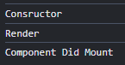

* If we have a child component inside the parent then the componentDidMount() of parent is called after completing the child component life cycle methods

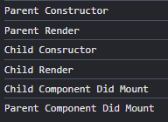

**componentDidMount()**

* To execute some code(make API calls) once we mounted the component successfully
* Is used to make API calls
* Similar to useEffect(<cb>, []) callback with empty dependency array
* It basically helps us to gives a better user experience by render the component quickly then makes the API call and fill the data

**Multiple Child**

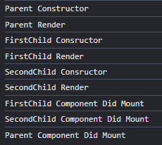

**Mounting Cycle**

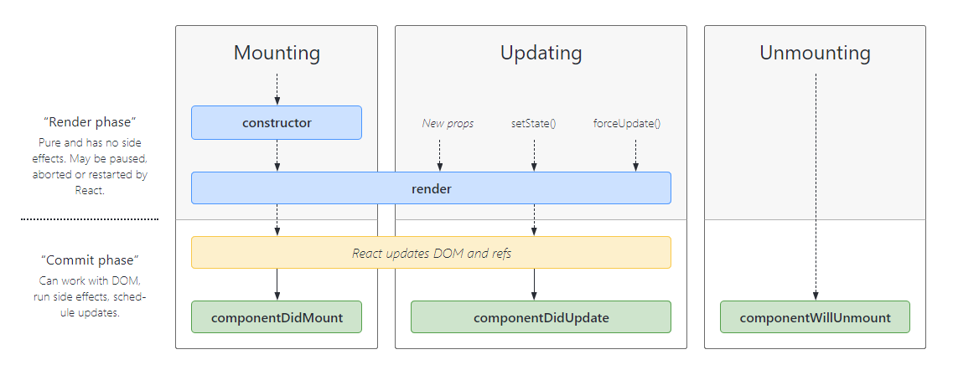

* Mounting happens in two phases
  + Render Phase
  + Commit Phase

**Render Phase**

* Combine all child components in current parent to make it a batch rendering.
* React is doing like this for the performance enhancements as updating the DOM is a costly process. React will batch it
* Virtual DOM Update

**Commit Phase**

* Batch all the child components and do the commit
* Real DOM Update

**Making API calls in Class based components**

* We will be making API calls in componentDidMount()

async componentDidMount() {

    const data = await fetch("https://api.github.com/users/mikhil-m");

    const json = await data.json();

    this.setState({

      userInfo: json,

    });

  }

**Update Cycle**

* It will triggered on updating the state with setState()
* Which will also call the render() method to update the virtualDOM
* After the render() method it will update the Real DOM and call componentDidUpdate

**Unmounting Cycle**

* It will happen when the component will disappear from the HTML
* Here the componentWillUnmount() method is called just before unmounting our component
* It helps us to cleanup setIntervals() or similar stuffs on navigating to different component

Ex:

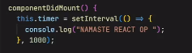



/**

 * -----MOUNTING----

 *

 *  Constructor(dummy)

 *  Render(dummy)

 *  <HTML Dummy >

 *  componentDidMount(dummy)

 *    <API Call>

 *    <this.setState> -> Update state variable

 *

 * -----UPDATING----

 *

 *  render(API Data)

 *  <HTML API Data>

 *  componentDidUpdate(API Data)

 *

 * -----UNMOUNTING----

 *

 *  componentWillUnmount()

 */

**useEffect vs Class based component lifecycle method**

* useEffect have the capability to do more functionalities than one lifecycle method
* If useEffect is without dependency array it will act as both …DidMount() and …DidUpdate()
* useEffect callback can be called based in dependency array but in class based.

We have to add the conditions manually in componentDidMount() by comparing previous and current state

* If we have to do different set of logic based on different dependency variables then we can make use of different useEffect methods for each but in class based, we hae to add more conditions

Ex: Class Based

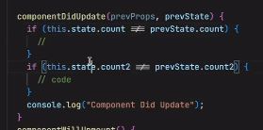

Ex Functional Based

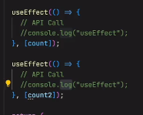

**Alternative for componentWillUnmount in Functional components**

* If we want to clear our set intervals in the useEffect() functional components then we can return a callback from functional components where we should define the clear interval and will get called automatically on component unmount

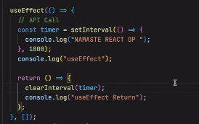

**Why async callbacks cannot be used in useEffect**

* The useEffect hook expects its effect function to return either a cleanup function or nothing at all

**OPTIMIZING OUR APP**

**Custom Hooks**

* Hooks are just utility functions
* Custom hooks will make our code more modular, readable, reusable and testable
* As per convention hooks are created inside util folder and for each hook we will use separate file with same name as the hook
* Hook name will start with ‘use’ so that react can understand but it’s not mandatory

Custom hook usage ex:

const resInfo = useRestaurantMenu(params.resId);

Hook definition ex:

import { useEffect, useState } from "react";

import { MENU_URL } from "./constants";

const useRestaurantMenu = (resId) => {

  const [resInfo, setResInfo] = useState(null);

  useEffect(() => {

    fetchMenu();

  }, []);

  const fetchMenu = async () => {

    const data = await fetch(MENU_URL + resId);

    const json = await data.json();

    setResInfo(json.data);

  };

  return resInfo;

};

export default useRestaurantMenu

* Custom hooks will have its own state, useEffect and lifecycle

**Chunking**

* Splitting our app into smaller logical chunks
* Alternate names
  + Code splitting
  + Dynamic Bundling
  + Lazy loading
  + On demand loading
  + Dynamic import

**Lazy Loading**

* To implement lazy loading we will be using lazy() method of react library
* The components to be lazy loaded are imported using lazy method

Ex:

const Grocery = lazy(() => import("./components/Grocery"));

* We should wrap our lazy loaded components using <Suspense/> component else it will throw an error as it is not immediately available while navigating
* We should pass a callback to the fallback of Suspense to display something while it tries to load the lazy loaded component as it requires some time to load the lazy loaded component
* Fallback is not mandatory

Ex:

{

        path: "/grocery",

        element: (

          <Suspense fallback={<h1>Loading...</h1>}>

            <Grocery />,

          </Suspense>

        ),

},